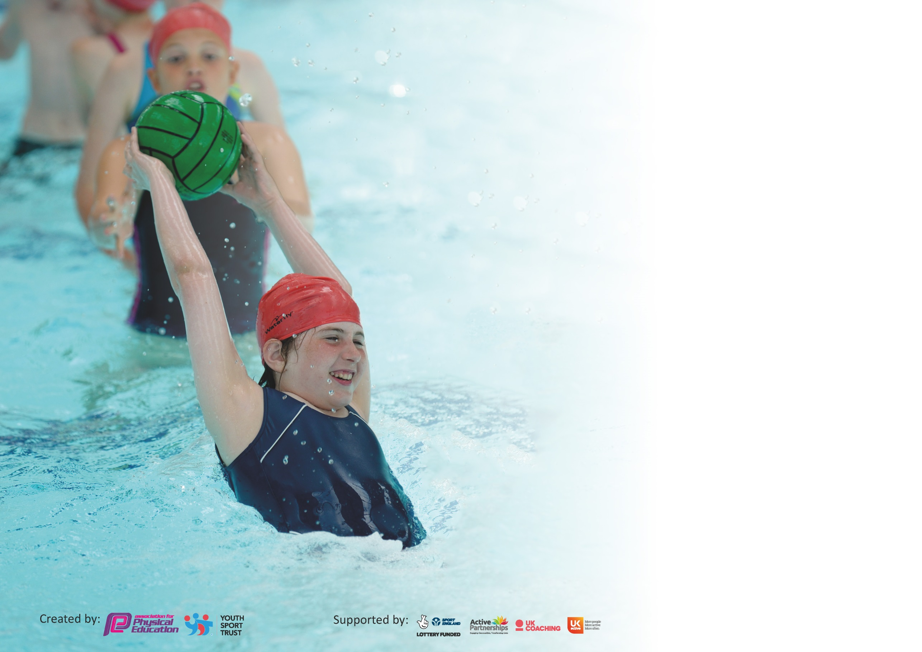

It is important that your grant is used effectively and based on school need. The Education Inspection Framework (Ofsted 2019 p64) makes clear there will be a focus on ‘whether leaders and those responsible for governors all understand their respective roles and perform these in a way that enhances the effectiveness of the school’.

Under the Quality of Education criteria (p41) inspectors consider the extent to which schools can articulate their curriculum (INTENT), construct their curriculum (IMPLEMENTATION) and demonstrate the outcomes which result (IMPACT).

To assist schools with common transferable language this template has been developed to utilise the same three headings which should make your plans easily transferable between working documents.

Schools must use the funding to make additional and sustainable improvements to the quality of Physical Education, School Sport and Physical Activity (PESSPA) they offer. This means that you should
use the Primary PE and Sport Premium to:

- Develop or add to the PESSPA activities that your school already offer
- Build capacity and capability within the school to ensure that improvements made now will benefit pupils joining the school in future years

Please visit gov.uk for the revised DfE guidance including the 5 key indicators across which schools should demonstrate an improvement. This document will help you to review your provision and to report your spend. DfE encourages schools to use this template as an effective way of meeting the reporting requirements of the Primary PE and Sport Premium.

We recommend you start by reflecting on the impact of current provision and reviewing the previous spend.

Schools are required to publish details of how they spend this funding as well as on the impact it has on pupils’ PE and sport participation and attainment by the end of the summer term or by 31st July 2020 at the latest.

We recommend regularly updating the table and publishing it on your website throughout the year. This evidences your ongoing self-evaluation of how you are using the funding to secure maximum, sustainable impact. Final copy must be posted on your website by the end of the academic year and no later than the 31st July 2020. To see an example of how to complete the table please click HERE.

Support for review and reflection - considering the 5 key indicators from DfE, what development needs are a priority for your setting and your pupils now and why? Use the space below to reflect on previous spend and key achievements and areas for development.

Key achievements to date until July 2020: | Areas for further improvement and baseline evidence of need:
Summer 2019 – our NFL team won the regional tournament and attended the national tournament at the Tottenham football ground in London  2019/2020 we have started our new sports partnership with St Thomas Moore as part of our MAT. This has involved creating a timetable for the year which enables all classes the chance to take part in competitive sport. | To continue to work with St Thomas Moore to strengthen our sports partnership.  Unable to complete the swimming and water safety data due to school closure (COVID-19) as the year 6 cohort were due to swim in the summer term.

Meeting national curriculum requirements for swimming and water safety.
What percentage of your current Year 6 cohort swim competently, confidently and proficiently over a distance of at least 25 metres?  N.B. Even though your pupils may swim in another year please report on their attainment on leaving  primary school at the end of the summer term 2020. | %
What percentage of your current Year 6 cohort use a range of strokes effectively [for example, front crawl, backstroke and breaststroke]? | %
What percentage of your current Year 6 cohort perform safe self-rescue in different water-based situations? | %
Schools can choose to use the Primary PE and Sport Premium to provide additional provision for swimming but this must be for activity over and above the national curriculum requirements. Have you used it in this way? | Yes/No

Action Plan and Budget Tracking
Capture your intended annual spend against the 5 key indicators. Clarify the success criteria and evidence of impact that you intend to measure to evaluate for pupils today and for the future.

Academic Year: 2019/20 | Total fund allocated: £17790 | Date Updated: 21.6.20
Key indicator 1: The engagement of all pupils in regular physical activity – Chief Medical Officer guidelines recommend that primary school pupils undertake at least 30 minutes of physical activity a day in school |  |  |  | Percentage of total allocation:
 |  |  |  | 4.4%
Intent | Implementation |  | Impact
Your school focus should be clear what you want the pupils to know and be able to do and about  what they need to learn and to  consolidate through practice: | Make sure your actions to achieve are linked to your intentions: | Funding allocated: | Evidence of impact: what do pupils now know and what can they now do? What has changed?: | Sustainability and suggested next steps:
- All children to take part in regular physical activity  - To improve the health and fitness of the children | - Scheduled sports at lunch time run by sports leaders and the sports coach (range of activities to encourage all children)  - To use the Rising stars scheme of work and to offer a wide range of after school clubs | £800 | Different children accessing the lunchtime activities | To continue to build on the lunchtime activities and to encourage more children to take part
Key indicator 2: The profile of PESSPA being raised across the school as a tool for whole school improvement |  |  |  | Percentage of total allocation:
 |  |  |  | 83.1%
Intent | Implementation |  | Impact
Your school focus should be clear what you want the pupils to know and be able to do and about  what they need to learn and to  consolidate through practice: | Make sure your actions to achieve are linked to your intentions: | Funding allocated: | Evidence of impact: what do pupils now know and what can they now do? What has changed?: | Sustainability and suggested next steps:
- To increase the quality of PE sessions being delivered  - To ensure all sessions are consistent and offer all children to reach their potential  - To offer a wide range of sports to all children and to create an enthusiastic approach across the school  - To begin a new sports partnership across the MAT | - To employ a sports coach to deliver 1 session per week for each class  - Buy a new PE scheme which focuses on improving health and fitness  - To ensure a wide range of clubs throughout the year (dance club, NFL club, multi skills, running club, Lets get healthy club, football, rugby)  - Scheduling competitive events for all classes | - £12,000  - £600  - £700  - 1500 | Children’s fitness is beginning to improve (based on fitness tests carried out in PE sessions) They children are more aware of their health and fitness. More children are taking part in after school clubs. | To continue with the sports coach.  To continue using the Rising Stars scheme of work.  To continue to build on our sports partnership and offer more events.

Key indicator 3: Increased confidence, knowledge and skills of all staff in teaching PE and sport |  |  |  | Percentage of total allocation:
 |  |  |  | 70.8%
Intent | Implementation |  | Impact
Your school focus should be clear | Make sure your actions to | Funding | Evidence of impact: what do | Sustainability and suggested
what you want the pupils to know | achieve are linked to your | allocated: | pupils now know and what | next steps:
and be able to do and about | intentions: |  | can they now do? What has
what they need to learn and to |  |  | changed?:
consolidate through practice:
- Upskill all teaching staff in a range of sports in order to upskill the children and expand their knowledge of fitness and sport | - Employ a sports coach to assist with the teaching of PE  - To implement the Rising Stars scheme of work – staff CPD on how to use the scheme | - £12,000  - £600 | All staff are following the Rising Stars scheme of work with confidence and using the online CPD to assist with their teaching. | To continue to use the Rising Stars scheme of work
Key indicator 4: Broader experience of a range of sports and activities offered to all pupils |  |  |  | Percentage of total allocation:
 |  |  |  | 20.2%
Intent | Implementation |  | Impact
Your school focus should be clear | Make sure your actions to | Funding | Evidence of impact: what do | Sustainability and suggested
what you want the pupils to know | achieve are linked to your | allocated: | pupils now know and what | next steps:
and be able to do and about | intentions: |  | can they now do? What has
what they need to learn and to |  |  | changed?:
consolidate through practice:
- To offer a range of after school clubs  - To offer a range of sports and fitness activities in weekly PE lessons  - To offer a range of competitive opportunities  - Extra sporting opportunities throughout the year | - Clubs to offer – NFL, dance, running, Lets get healthy, multi skills, football, rugby, hockey, ball games, netball  - To use the Rising Stars scheme of work which offers a range of fitness activities and sports  Termly swimming sessions for KS2  - Each class to attend an event with the MAT school  To attend the NFL regional tournament  To arrange football/ netball matches against other local schools  - Children in need Joe Wicks  UNICEF playground challenge | - £700  - £1400  - 1500 | Children have a wider knowledge of a range of sports – in particular NFL which the children are extremely enthusiastic about  The Rising Stars scheme of work has given the children more awareness of their fitness and this is evident in their PE sessions. | To continue to offer a range of clubs  To continue with Rising Stars  To continue to subsidise swimming lessons  To continue to build the sports partnership

Key indicator 5: Increased participation in competitive sport |  |  |  | Percentage of total allocation:
 |  |  |  | 9.5%
Intent | Implementation |  | Impact
Your school focus should be clear | Make sure your actions to | Funding | Evidence of impact: what do | Sustainability and suggested
what you want the pupils to know | achieve are linked to your | allocated: | pupils now know and what | next steps:
and be able to do and about | intentions: |  | can they now do? What has
what they need to learn and to |  |  | changed?:
consolidate through practice:
- To continue to build on our NFL success from last year  - To build our new sports partnership within the MAT  - To branch out to local schools | - To enter the NFL regional tournament  - Every class to take part in a competitive event within the MAT  - To arrange competitive sports (football/netball) with local schools and using our links with Key Sports | - £200  - £1500 | - Unable to compete due to school closure  - Year 1, 2 , 4 and 6 have taken part in events ( the others years not gone ahead due to school closure)  - Not gone ahead due to school closure | To continue with all 3 actions next year

Signed off by
Head Teacher:
Date:
Subject Leader:
Date:
Governor:
Date:

