 | Core Knowledge: Topic Two | Threads | NC objectives | Skills | Vocabulary
Y1 | Through the Keyhole: School Days:  Know the name of our school and its original name, when it was built and how old it is.  Know some of the ways that our school has changed over time: its name, the headteacher, the classrooms, the field, the playground.  Know about schools 100 years ago and schools today: what a classroom looked like, what equipment teachers used, what equipment children used, what lessons were taught. |   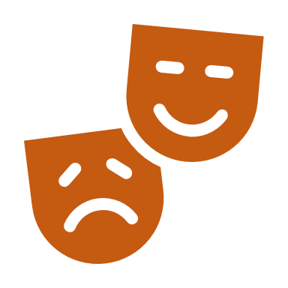    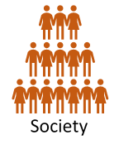  Artefacts and evidence  Culture and pastimes  Change | Changes within living memory. Where appropriate, these should be used to reveal aspects of change in national life | To understand the concept of history (past and present)  To recognise the difference between past and present in their own and others lives  To know and recount episodes from stories about the past  To find answers to simple questions about the past from sources of information | St William’s, Catholic, St John The Baptist Trust, Headteacher, Victorian, classroom, chalk, chalkboard, slate,
 | Core Knowledge: Topic Four | Threads | NC objectives | Skills | Vocab
Y1 | Through the Keyhole: London over Time  The Gunpowder Pot-  Know that The Gunpowder Plot took place in London on the 5th November 1605  Know who Robert Catesby and Guy Fawkes were  Know that The Gunpowder Plot was a plot to kill King James I and his government by blowing up the Houses of Parliament.  Know why The Gunpowder Plot happened-  Know that the plot failed.  Know that Guy Fawkes was executed for his crime  Know what happens on the 5th November and what we are remembering  The Great Fire of London-  Know that the GFoL happened in 1666  Know where and how the fire started  Know the main events of the fire in a simple timeline  Know who Samuel Pepys was and what he did during the GFoL  Know why the fire spread so quickly  Know how people tried to stop the fire  Know how the fire ended  Know about some of the changes that happened in London after the fire ended  The London Olympics:  Know that the LO took place in 2012  Know some of the places where the Olympic Games took place  Know what the Olympic games are-  Know that ancient Olympics took place in Greece over 2000 years ago.  Know that the modern Olympics started in Greece over 100 years ago  Know why the Olympic games are important  The Coronation of King Charles III:  Know why King Charles became king  Know that Queen Elizabeth was his mother and died in September 2022  Know where an when the coronation took place  Know what the coronation ceremony is | 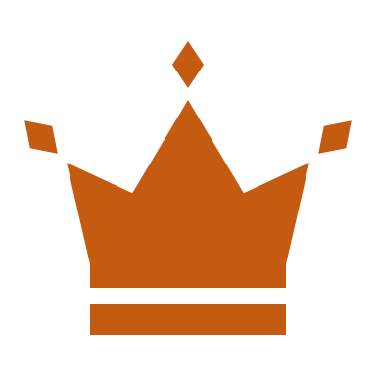  Artefacts and evidence  Power | Events beyond living memory that are significant nationally or globally | Sequence 3 or 4 artefacts from distinctly different periods of time  Recognise the difference between past and present in their own and others’ lives  To know and recount episodes from stories about the past  Find answers to simple questions about the past from sources of information e.g. artefacts | London, Gunpowder plot, Robert Catesby, Guy Fawkes, King James I, government, Houses of Parliament, executed, crime, Great Fire of London, Samuel Pepys, Olympics, Greece, Ancient, Coronation, King Charlies III, Queen Elizabeth, ceremony

 | Core Knowledge: Topic One | Threads | NC Objectives | Skills | Vocabulary
Y2 | Through the Keyhole: Kings and Queens  Know that our current monarch is King Charles III who became king after Queen Elizabeth II (his mother) died in 2022.  Know that Queen Elizabeth II was the longest reigning monarch. She reigned for 70 years.  Know who Queen Victoria was and that she was queen for almost 64 years (1837-1901). This time was called the Victorian period. Cars and trains were invented during this time.  Know who King Henry VIII (1509-1547) was and that he was desperate for a son, so when his wife Katherine of Aragon gave birth to a baby girl,  he divorced her. In doing so, he split England from the Catholic Church and created the Church  of England.  Henry had a total of six wives; he divorced two and beheaded two.  Elizabeth I (1558-1603) was the daughter of Henry VIII.  She never married and didn’t have any children. | 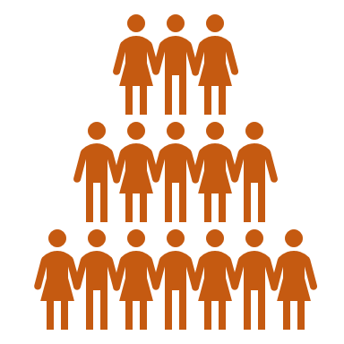  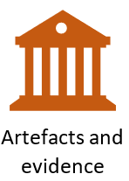  Change  Society | The lives of significant individuals in the past who have contributed to national and international achievements. Some should be used to compare aspects of life in different periods [for example, Elizabeth I and Queen Victoria,  Events beyond living memory that are significant nationally or globally | To understand how a historical timeline works.  To be able to create a simple timeline of key events for each monarch  To use a source – observe or handle sources to answer questions about the past on the basis of simple observations.  To recognise why people did things, why events happened and what happened as a result | King, Queen, monarch, reign, coronation, jubilee, Victorian period, divorced, beheaded, died, Catholic Church, Church of England,

 | Core Knowledge: Topic Two | Threads | NC objectives | Skills | Vocabulary
Y2 | Amelia Earhart:  Know that Amelia Earhart was born in America, she had a passion for flying from an early age  First woman (and only the second person) to fly solo across The Atlantic Ocean  Broke many flying records including being the first person to fly solo from Hawaii to California  Died in 1937 when her plane disappeared while she was attempting to fly around the world.  Rosa Parks:  Know that she was born in 1913 in Alabama in the USA  She lived in a time of segregation when black and white people were not treated equally  Arrested because she refused to give up her seat on a bus for a white man which led to a bus boycott by black people,  1956 the segregation law changed but she continued to fight for equal rights, she died in 2005.  Greta Thunberg: Know that she was born in Stockholm, Sweden in 2003, when she was 11 she became an environmental activist because she was very sad about the problem of climate change, in 2018 she went on strike from school and sat outside the Swedish Parliament with a sign that said ‘School Strike for Climate, since then she has made TV documentaries and written books about the problem of climate change. |   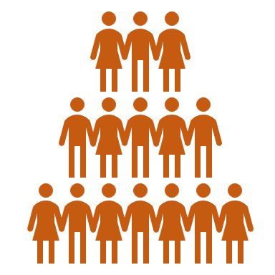  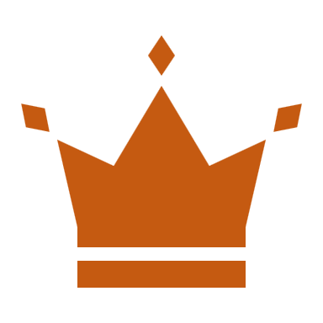    Change  Society  Power  Artefacts and evidence | The lives of significant individuals in the past who have contributed to national and  international achievements. Some should be used to compare aspects of life in  different periods | To understand how a historical timeline works.  To create a simple timeline of key events for each significant individual  To use a source – observe or handle sources to answer questions about the past on the basis of simple observations.  To compare pictures or photographs of people or events in the past  To discuss reliability of photos/ accounts/stories  To recognise why people did things, why events happened and what happened as a result  Identify differences between ways of life at different times | Aeroplane, flight, solo, segregation, boycott, strike, equal rights, climate change, environmental activist, law, Atlantic ocean, activities, United States of America, Sweden,
3 | Leaving a Legacy: Stone Age to Iron Age  Know when the Stone Age, Bronze Age and Iron Age began and ended  Know that the earliest settlers were hunter gatherers and lived in caves  Know that Stone Age man produced cave art  Know how life changed in The Stone Age when man began to farm  Know what life was like in Skara Brae (Neolithic village)  Know how, where, when and why Stonehenge was built  Know that people in the Bronze Age lived in roundhouses  Know what life was like living in a roundhouse  Know that people in the Iron Age lived in farming communities on hilltops called hill forts  Know what life was like living in a Bronze Age hill fort |   Settlements  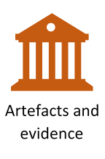    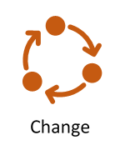 | Changes in Britain from the Stone Age to the Iron Age | To create a timeline from the stone Age to Iron Age including key time periods/ events  To use different sources including artefacts, art and written sources to find out historical information  To identify the key features and the similarities and differences between the key periods of time  To look at representations of the period – museum, cartoons etc  To begin to use the library and internet for research | Stone Age, Iron Age,  Bronze Age, cave art, hunter gathers, Skara Brae, roundhouse, prehistoric, settlement, tribe, archaeologist, palaeolithic, Mesolithic, Neolithic,
 | Core Knowledge: Topic Three | Threads | NC objectives | Skills | Vocab
Y3 | Leaving a Legacy: Ancient Greece  Know where and when the Ancient Greeks lived  Know the dates of key events in the Ancient Greek timeline  Know that Ancient Greece was made up of city states. The most important city states were: Athens, Sparta and Corinth.  Know about the city state of Athens: The Athenians were known for their cultural developments and learning.  To know Athens is where democracy began in around 508 BC.  Know about the city state of Sparta  Know about the Trojan Wars  Know about the first Olympic Games: | 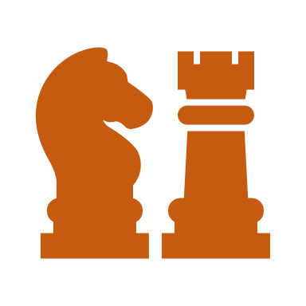    Culture and pastimes  Society  Artefacts and evidence  Conflict | Ancient Greece – a study of Greek life and achievements and their influence on the western world | To locate Greece on a world map  To create a timeline from the Ancient Greek time including key time periods/ events  To use different sources including artefacts, art and written sources to find out historical information  To identify the key features and the similarities and differences between the key periods of time | City states, democracy, debating, vote, warriors, legacy, citizens, surrender, cultural developments, Athenians, Spartans, Trojans, Trojan war, boxing, wrestling, chariot racing
4 | Leaving a Legacy: Ancient Egypt  Know who the Ancient Egyptians were, where they lived and when they lived.  Know what life in Ancient Egypt was like: such as jobs, houses, food, clothes  Know about the importance of The River Nile to The Ancient Egyptians  Know about the process of mummification  Know about Egyptian written communication- hieroglyphics  Know who Tutankhamun was and when he lived  Know how his tomb was discovered  Know what his tomb revealed about his life | 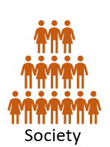  Power | The achievements of the earliest civilizations – an overview of where and when the first civilizations appeared and a depth study of Ancient Egypt | To develop a timeline of key events in the Ancient Egypt time period  To use different sources including artefacts, art and written sources to find out historical information  To place events from period studied on time line  To use terms related to the period and begin to date events  To understand more complex terms eg BC/AD  To use evidence to reconstruct life in time studied  To be able to identify key features and events of time studied  To be able to look for links and effects in time studied  To offer a reasonable explanation for some events | Ancient, pharaoh, hieroglyphics, pyramids, River Nile, Tutankhamun, tomb, mummification,  Civilisation,

 | Core Knowledge: Topic Two | Threads | NC objectives | Skills | Vocabulary
Y4 | Leaving a Legacy: Ancient Rome  Know who the Romans were and where they came from  Know when the Romans invaded Britain  Know why the Romans invaded Britain  Know that the Romans built Hadrian’s wall to defend themselves from invaders from the north  Know why and how the Romans built new roads and towns in Britain  Know who Boudicca was and know about the rebellion she led against the Romans  Know what life was like in a Roman Villa in Britain  Know about the ways in which the Roman Empire has had a lasting impact on Britain | 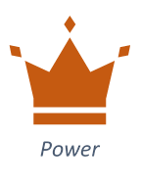  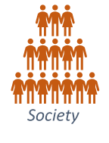  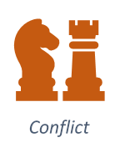    Artefacts and evidence    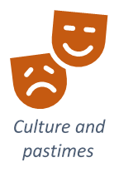 | The Roman Empire and its impact on Britain | To locate Italy and Rome on a map  To place events from period studied on time line  To use terms related to the period and begin to date events  To understand more complex terms eg BC/AD  To develop a timeline of key events in the Ancient Rome time period  To identify key features and events of time studied  To look for links and effects in time studied  To offer a reasonable explanation for some events  To begin to evaluate the usefulness of different sources  To use text books and historical knowledge | Romans, invasion, Hadrian’s wall,  Invaders, Boudicca, rebellion, villa, town, impact, legacy, Empire,

 | Core Knowledge: Topic One | Threads | NC Objectives | Skills | Vocabulary
5 | Leaving a Legacy: Anglo-Saxon Britain  Know when (450AD) and why the Anglo-Saxons invaded Britain  Know where The Anglo-Saxons came from  Know where the Anglo Saxons settled in Britain and the names of the places they settled in  Know about life in an Anglo-Saxon village: houses, jobs, food, clothing  Know about Anglo Saxon art and culture  Know how the Anglo-Saxons were converted to Christianity in Britain | 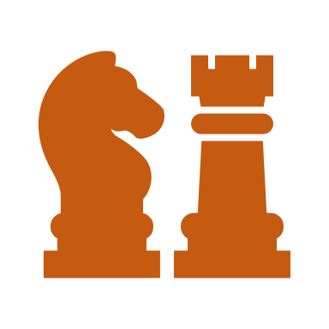  Locality  Change  Conflict  Settlements | Britain’s settlement by Anglo-Saxons and Scots | To draw a timeline to show when Anglo Saxon Britain was in history and how this links to other time periods studied.  To use different sources including artefacts, art and written sources to find out historical information  To compare the reliability of different sources of historical information.  To know and sequence key events of time studied  Use relevant terms and period labels  To be able to make comparisons between different times in the past  To be able to compare accounts of events from different sources – fact or fiction and offer some reasons for different versions of events  To be able to use the library and internet for research with increasing confidence | Invaded, invasion, settlement, settlers, Wergild, legacy, runes, Bayeux, tribes, Wessex, Mercia, Northumbria, Essex, Derbyshire, Leicestershire Kent, East Anglia Cambridgeshire,  Pagan
 | Core Knowledge: Topic Two | Threads | NC objectives | Skills | Vocabulary
Y5 | Leaving a Legacy: Industrial Revolution  Know that The Industrial Revolution was a period of huge change in Britain between 1750 and 1900.  Know that before the Industrial Revolution, Britain was a rural country. Most people lived off the land with livestock.  Know that Queen Victoria was the reigning monarch for a large part of the Industrial Revolution (1837-1901)  Know how the Industrial Revolution began-people began to realise that coal and steam could be used to power factories, large machines, flour and cotton mills.  Know that huge factories were built and where they were built.  Know about how certain towns rapidly expanded  Know that many people moved to the towns and why  Know what life was like for poor people in The Industrial Revolution  Know about some of the key inventions of The Industrial Revolution- such as the steam engine, the locomotive, the car (internal combustion engine), the electric telegraph, the typewriter, the Spinning Jenny |  | A study of an aspect or theme in British history that extends pupils’ chronological  knowledge beyond 1066  A significant turning point in British history, for example, The Industrial Revolution | To draw a timeline to show when the Industrial Revolution was in history and how this links to other time periods studied.  To use different sources including artefacts, art and written sources to find out historical information  To compare the reliability of different sources of historical information.  To know and sequence key events of time studied  To use relevant terms and period labels  To make comparisons between different times in the past  To study different aspects of different people - differences between men and women  To examine causes and results of great events and the impact on people | Industrial revolution, livestock, rural, town, city, steam, factory, Queen Victoria, Spinning Jenny, coal, steam, train, locomotive, engine, internal combustion engine, monarch, expanded, reign

6 | Leaving a Legacy: Invasion  Know that the Viking age began around 1200 years ago and lasted for just over 200 years.  Know where the Vikings settled in Britain and the names of the places they settled in  Know about the Viking attack on Lindisfarne in 793  Know about the capture of York in 867  Know about the treaty between Guthram and King Alfred of Wessex (Danelaw).  Know that Danegeld was money paid to stop the Vikings raiding.  Give reasons why the Vikings chose to attack Britain – combination of overpopulation at home to relative weakness of victims abroad.  Know how the Vikings lived: family life, homes, jobs  Know about Viking ships- long boats and cargo vessels  Know about Know about the treaty between Guthram and King Alfred of Wessex (Danelaw). | Conflict  Change  Power  Settlements | The Viking and Anglo-Saxon struggle for the Kingdom of England to the time of Edward the Confessor | To draw a timeline to show when the Viking Age was in history and how this links to other time periods studied.  To be able to place current study on time line in relation to other studies  To be able to use relevant dates and terms  To know key dates, characters and events of time studied  To be able to develop a timeline of key events in the Viking time period  To be able to compare the reliability of different sources of historical information.  To be able to recognise primary and secondary sources  To use a range of sources to find out about an aspect of time past  To be able to bring knowledge gathered from several sources together in a fluent account | Lindisfane, Guthram, King Alfred, Wessex, Dane Law,  Population, long boat, cargo vessel, Jorvik, exile, pagan

 | Core Knowledge: Topic Two | Threads | NC objectives | Skills | Vocabulary
Y6 | Leaving a Legacy: World War Two  Know why Britain went to war in 1939  Know why children were evacuated in World War Two  Know what life was like for evacuees  Know what life was like for people living in Britain in World War Two: rationing, blackouts, air raids,  Know about the Dunkirk evacuation- when it happened, why it happened, where it happened, what happened  Know about the Battle of Britain- when it happened, why it happened, where it happened, what happened  Know about the impact of the war on the city of Peterborough  Know about the impact of the war on Jewish people overseas-  Know about Kristallnacht- when it happened, why it happened, where it happened, what happened  Know about The Holocaust- when it happened, why it happened, where it happened, what happened  Know the events that brought World War Two to an end: The Battle of Stalingrad and the D-Day Invasion of No | Artefacts and evidence  Conflict  Power  Change | a study of an aspect or theme in British history that extends pupils’ chronological knowledge beyond 1066 | To place current study on time line in relation to other studies  To use relevant dates and terms  To sequence up to 10 events on a time line  To know key dates, characters and events of time studied  To use different sources including artefacts, art and written sources to find out historical information  To link sources and work out how conclusions were arrived at  To consider ways of checking the accuracy of interpretations – fact or fiction and opinion  To be aware that different evidence will lead to different conclusions  Confidently use the library and internet for research  To recognise primary and secondary sources  To use a range of sources to find out about an aspect of time past  To suggest omissions and the means of finding out  To compare the reliability of different sources of historical information. | War, evacuees, rationing, blackouts, air- raids, Dunkirk, evacuation, impact, Kristallnacht, The Holocaust, Battle of Stalingrad, D Day, invasion, Normandy

