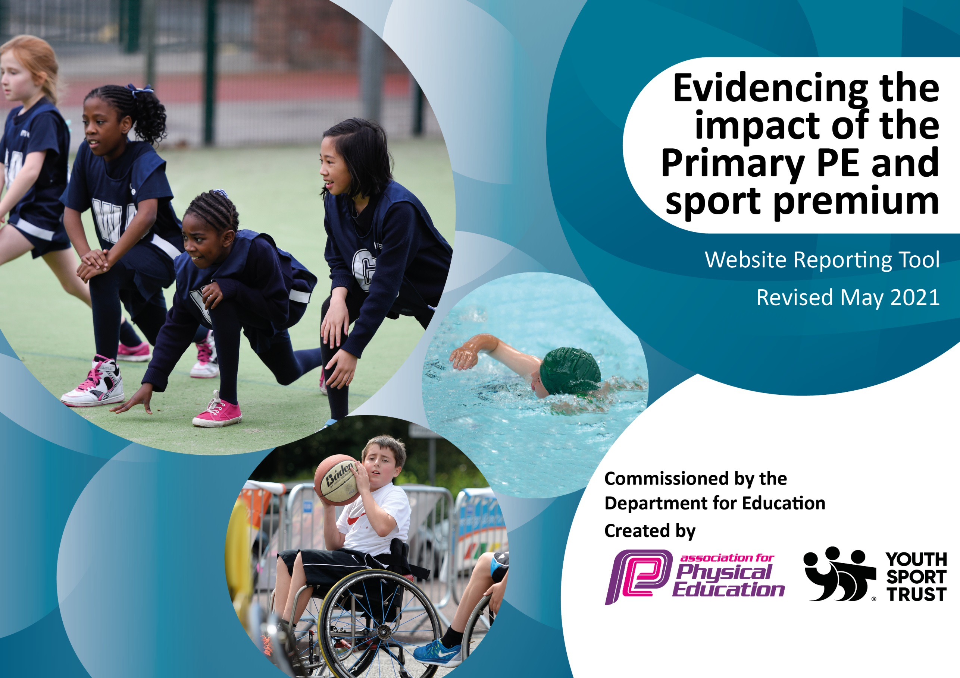

It is important that your grant is used effectively and based on school need. The Education Inspection Framework (Ofsted 2019 p64) makes clear there will be a focus on ‘whether leaders and those responsible for governors all understand their respective roles and perform these in a way that enhances the effectiveness of the school’.

Under the Quality of Education criteria (p41) inspectors consider the extent to which schools can articulate their curriculum (INTENT), construct their curriculum (IMPLEMENTATION) and demonstrate the outcomes which result (IMPACT).

To assist schools with common transferable language this template has been developed to utilise the same three headings which should make your plans easily transferable between working documents.

Schools must use the funding to make additional and sustainable improvements to the quality of Physical Education, School Sport and Physical Activity (PESSPA) they offer. This means that you should use the Primary PE and sport premium to:

- Develop or add to the PESSPA activities that your school already offer
- Build capacity and capability within the school to ensure that improvements made now will benefit pupils joining the school in future years
- The Primary PE and sport premium should not be used to fund capital spend projects; the school’s budget should fund these.
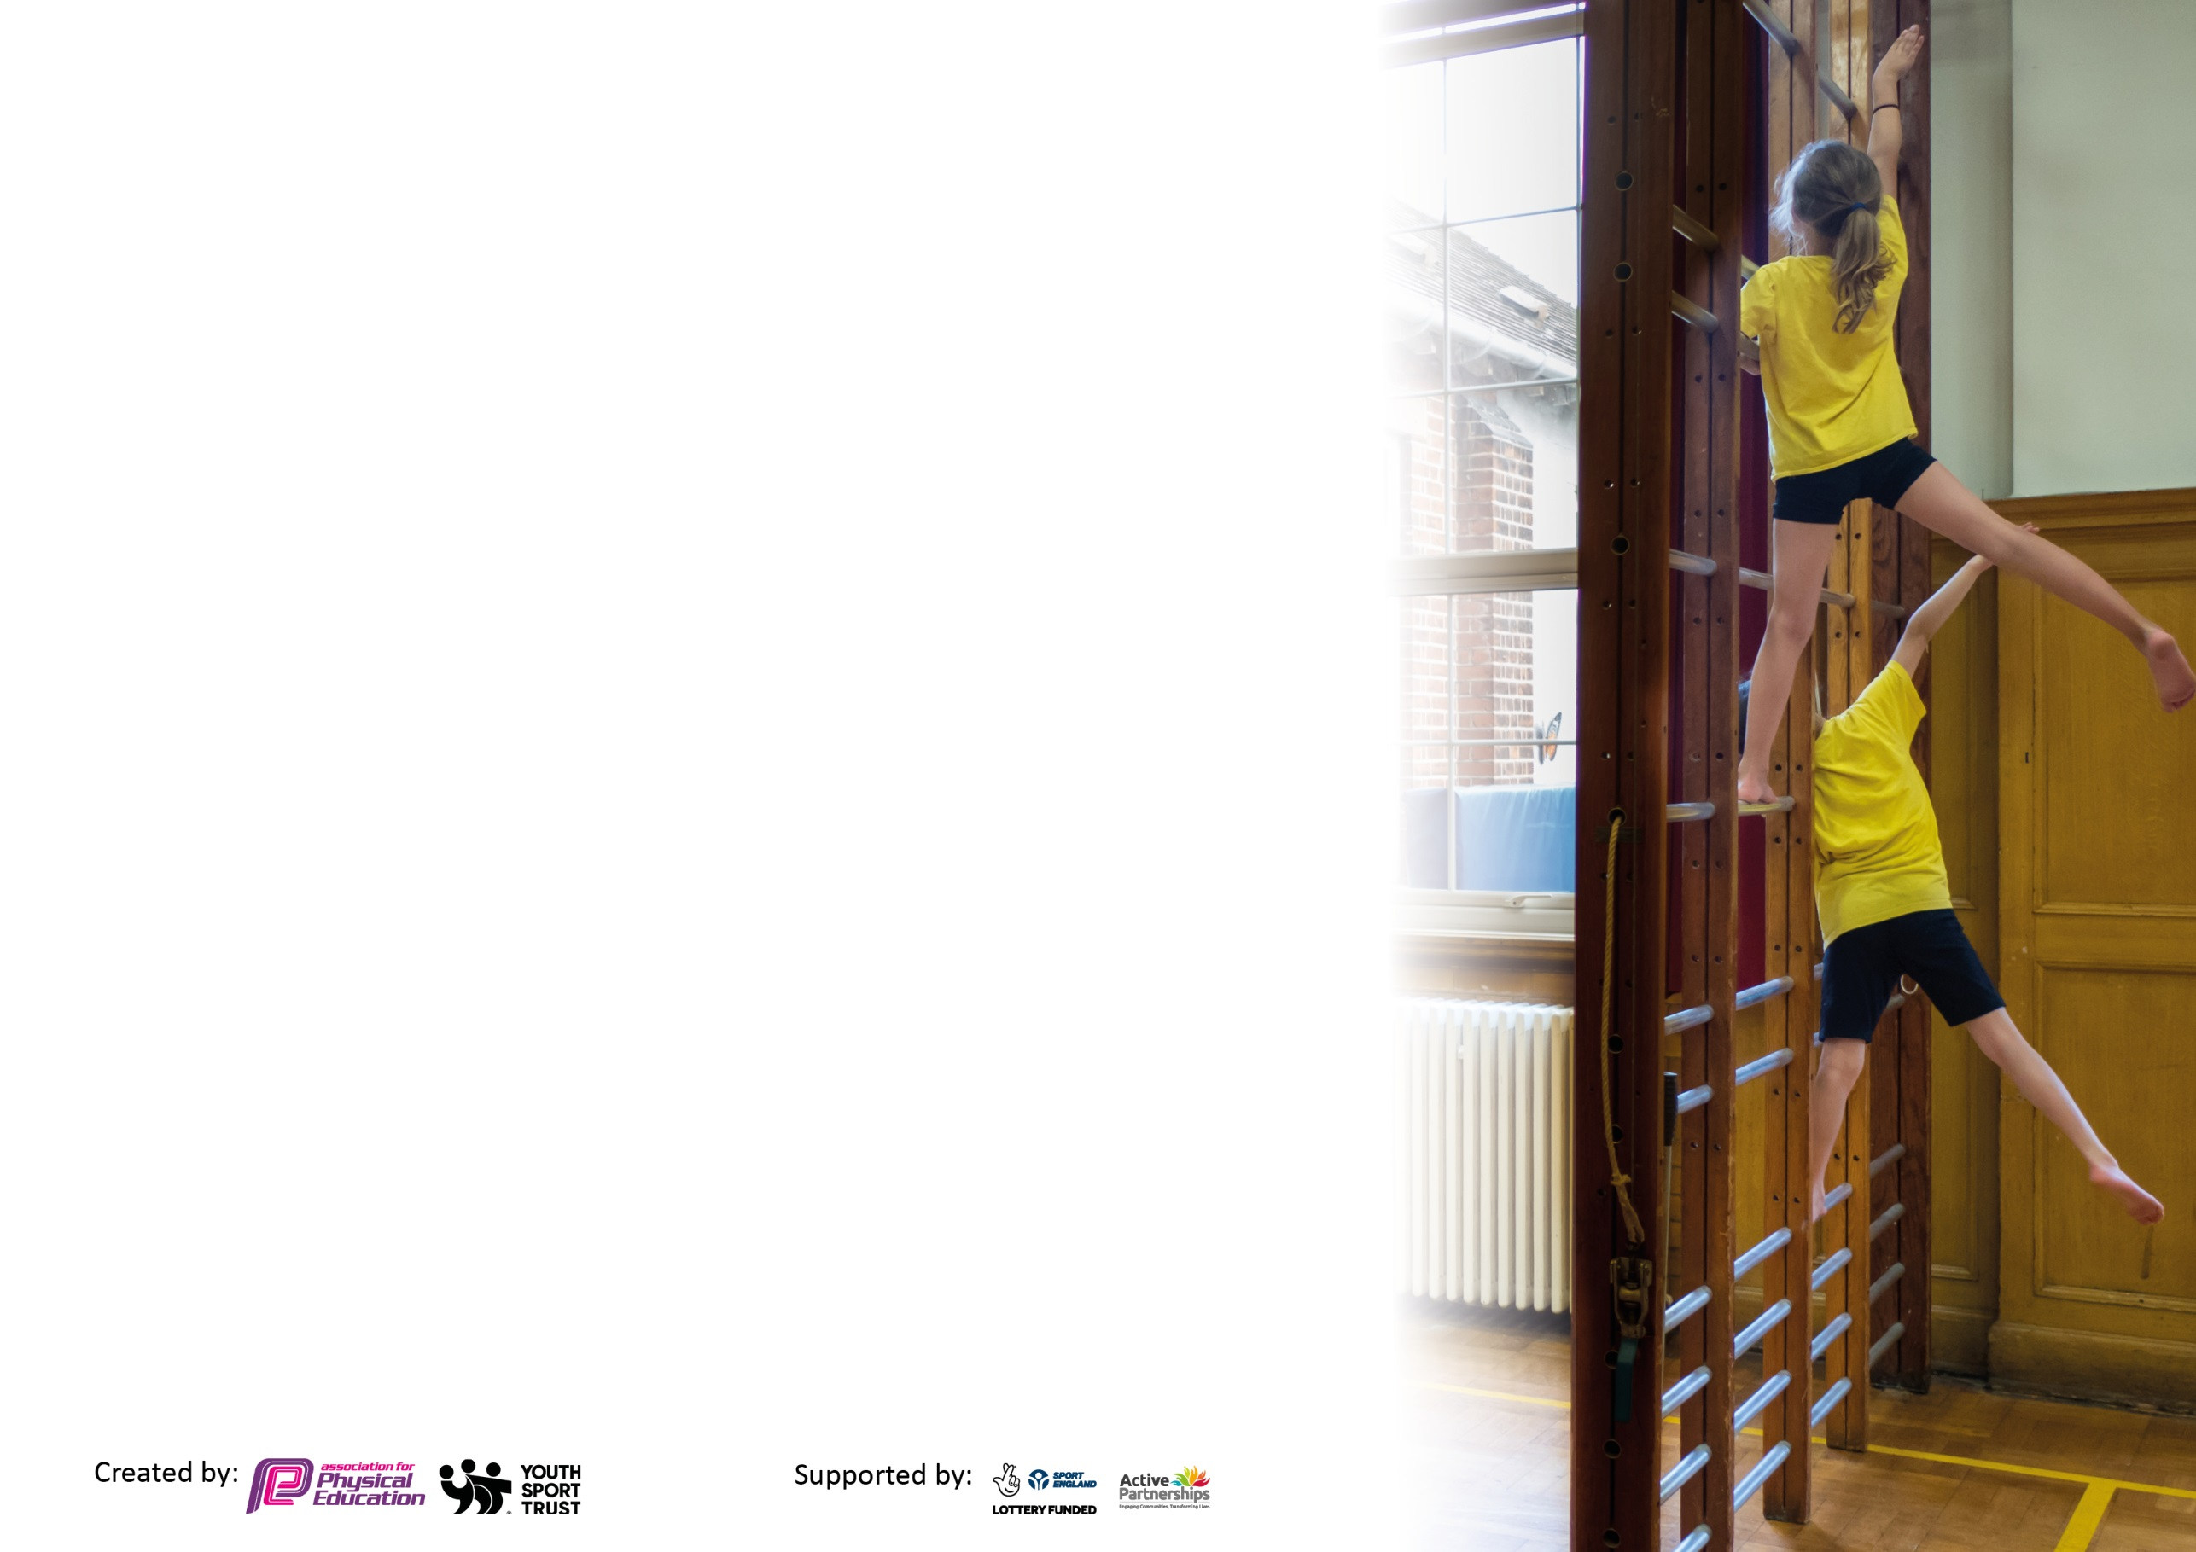
Please visit gov.uk for the revised DfE guidance including the 5 key indicators across which schools should demonstrate an improvement. This document will help you to review your provision and to report your spend. DfE encourages schools to use this template as an effective way of meeting the reporting requirements of the Primary PE and sport premium.

We recommend you start by reflecting on the impact of current provision and reviewing the previous spend.

Schools are required to publish details of how they spend this funding, including any under-spend from 2019/2020, as well as on the impact it has on pupils’ PE and sport participation and attainment by the end of the summer term or by 31st July 2021 at the latest.

We recommend regularly updating the table and publishing it on your website throughout the year. This evidences your ongoing self-evaluation of how you are using the funding to secure maximum, sustainable impact. Final copy must be posted on your website by the end of the academic year and no later than the 31st July 2021. To see an example of how to complete the table please click HERE.



Please note: Although there has been considerable disruption in 2021 it is important that you publish details on your website of how you spend the funding - this is a legal requirement.
Support for review and reflection - considering the 5 key indicators from DfE, what development needs are a priority for your setting and your pupils now and why? Use the space below to reflect on previous spend and key achievements and areas for development.

N.B. In this section you should refer to any adjustments you might have made due to Covid-19 and how these will influence further improvement.
Key achievements to date until July 2021: | Areas for further improvement and baseline evidence of need:
This year we have successfully implemented the daily mile across the school. Every day, each class has a designated time to go outside and complete their mile.  Since returning to school, all classes have continued with their 2 hours of PE each week. New equipment was purchased to support the COVID restrictions and ‘Bubble’ system in place.  New outdoor gym equipment has been purchased to support the improvement of children’s fitness levels. | To increase the fitness levels of all children as a result of the Lockdown period.

Did you carry forward an underspend from 2019-20 academic year into the current academic year? YES
Total amount carried forward from 2019/2020 £8900
+ Total amount for this academic year 2020/2021 £17790
= Total to be spent by 31st July 2021 £26700

Meeting national curriculum requirements for swimming and water safety.

N.B Complete this section to your best ability. For example you might have practised safe self-rescue techniques on dry land which you can transfer to the pool when school swimming restarts.
Due to exceptional circumstances priority should be given to ensuring that pupils can perform safe self rescue even
if they do not fully meet the first two requirements of the NC programme of study.
What percentage of your current Year 6 cohort swim competently, confidently and proficiently over a distance of at least 25 metres?  N.B. Even though your pupils may swim in another year please report on their attainment on leaving primary school at the end of the summer term 2021.  Please see note above. | 65%
What percentage of your current Year 6 cohort use a range of strokes effectively [for example, front crawl, backstroke and breaststroke]?  Please see note above. | 65%
What percentage of your current Year 6 cohort perform safe self-rescue in different water-based situations? | 30%
Schools can choose to use the Primary PE and sport premium to provide additional provision for swimming but this must be for activity over and above the national curriculum requirements. Have you used it in this way? | No

Action Plan and Budget Tracking
Capture your intended annual spend against the 5 key indicators. Clarify the success criteria and evidence of impact that you intend to measure to evaluate for pupils today and for the future.

Academic Year: 2020/21 | Total fund allocated: £26700 | Date Updated:13.7.21
Key indicator 1: The engagement of all pupils in regular physical activity – Chief Medical Officers guidelines recommend that primary school pupils undertake at least 30 minutes of physical activity a day in school |  |  |  | Percentage of total allocation:
 |  |  |  | 76.7%
Intent | Implementation |  | Impact
Your school focus should be clear what you want the pupils to know and be able to do and about  what they need to learn and to  consolidate through practice: | Make sure your actions to achieve are linked to your intentions: | Funding allocated: | Evidence of impact: what do pupils now know and what can they now do? What has changed?: | Sustainability and suggested next steps:
To increase the children’s fitness levels | - To introduce the daily mile across the school  - To purchase new equipment to be used in lessons and playtimes  - To fund after school clubs run by a sports coach  - To purchase outdoor gym equipment  - To purchase a new PE scheme of work for the next 3 years  - To purchase PE tops for all children for the academic year 21/22  - To fund a sports coach to deliver PE sessions | 2. £1600  3. £1410  - £5856  - £825  - £882  - 9920 | - All classes have taken part in the daily mile and they look forward to it every day.  - Classes had access to their own equipment  - Since clubs restarted after the lockdown period, 160 children have attended clubs  - All children have had access to the outdoor gym equipment | - to continue with daily mile  - new equipment to be used in lessons and clubs  - to continue to fund all after school clubs  - children to continue to have access to the gym equipment at lunch and play times
Key indicator 2: The profile of PESSPA being raised across the school as a tool for whole school improvement |  |  |  | Percentage of total allocation:
 |  |  |  | 49.2%
Intent | Implementation |  | Impact
Your school focus should be clear what you want the pupils to know and be able to do and about  what they need to learn and to  consolidate through practice: | Make sure your actions to achieve are linked to your intentions: | Funding allocated: | Evidence of impact: what do pupils now know and what can they now do? What has changed?: | Sustainability and suggested next steps:
To widen the children’s sporting opportunities and exposure  To increase children’s fitness levels | - To reintroduce swimming after the lockdown period  - To purchase new equipment to be used across the school  - To fund all sports clubs  - To purchase outdoor gym equipment  - To purchase a new PE scheme of work for the next 3 years  - To buy into the Jack Hunt sport cluster for the academic year 21/22 | - £645  - £1610  - £1410  - £5856  - £825  - £2800 | - Year 6 have taken part in 6 weeks of swimming  - New equipment has been used by all children in lessons, clubs and at lunch times  - 160 children have taken part in free clubs  - The new outdoor gym equipment has been used by all children across the school | - All ks2 classes to have 8 weeks of swimming  - To continue to use full range of equipment  - To continue to fund all sport clubs  - All children to continue to have full access to the gym equipment  - To introduce the new PE scheme across the school  - Children to take part in school competitions and events at Jack Hunt

Key indicator 3: Increased confidence, knowledge and skills of all staff in teaching PE and sport |  |  |  | Percentage of total allocation:
 |  |  |  | 4.5 %
Intent | Implementation |  | Impact
Your school focus should be clear | Make sure your actions to | Funding | Evidence of impact: what do | Sustainability and suggested
what you want the pupils to know | achieve are linked to your | allocated: | pupils now know and what | next steps:
and be able to do and about | intentions: |  | can they now do? What has
what they need to learn and to |  |  | changed?:
consolidate through practice:
To upskill teacher’s confidence and PE skills | - To purchase a new scheme of work that offers teacher support and CPD opportunities  - Staff CPD-  Monitoring and assessing course  Covid- Pe at home  Val Sabin – EYFS | - £825  - £382 | - To be implemented in September  - The PE lead has carried out a deep dive and provided at home resources for staff to use during the lockdown period | - To be implemented in September  - To continue with the monitoring and assessing of PE
Key indicator 4: Broader experience of a range of sports and activities offered to all pupils |  |  |  | Percentage of total allocation:
 |  |  |  | 18.8%
Intent | Implementation |  | Impact
Your school focus should be clear | Make sure your actions to | Funding | Evidence of impact: what do | Sustainability and suggested
what you want the pupils to know | achieve are linked to your | allocated: | pupils now know and what | next steps:
and be able to do and about | intentions: |  | can they now do? What has
what they need to learn and to |  |  | changed?:
consolidate through practice:
To offer a wide range of clubs to all ages  To offer a PE curriculum that covers a wide range of sports  To offer children the experience of competitions | - To provide free after school clubs for each class  - To purchase a new PE scheme for September that links closely to the national curriculum as well as offering a broader range of sports  - To buy back into the Jack Hunt cluster so children have regular opportunities to compete against other schools and take part in a range of sporting events | - £1410  - £825  - £2800 | - 160 children across the school took part in after school clubs  - Get set PE has been purchased for the next 3 years – to be implemented in September  - We have bought into the Jack Hunt cluster for September 21 | - To continue to provide free after school clubs  - To implement Get set PE  - To work closely with Jack Hunt to provide a range of opportunities

Key indicator 5: Increased participation in competitive sport |  |  |  | Percentage of total allocation:
 |  |  |  | 10.4%
Intent | Implementation |  | Impact
Your school focus should be clear | Make sure your actions to | Funding | Evidence of impact: what do | Sustainability and suggested
what you want the pupils to know | achieve are linked to your | allocated: | pupils now know and what | next steps:
and be able to do and about | intentions: |  | can they now do? What has
what they need to learn and to |  |  | changed?:
consolidate through practice:
To provide greater opportunities for all children to take part in a wide range of in and out of school competitions | 1.To provide competition between classes  2. To arrange competitions between other schools  3. to buy into the Jack Hunt cluster for September 21 | 3. £2800 | Not happened due to COVID restrictions | To be implemented next year


